UNIVERSITY OF PETROLEUM AND ENERGY STUDIES


Student Name: Deepanshi Shukla
Sap ID: - 590021964
Batch: B10
Course: B. Tech (CSE)
SUBJECT: python Programming lab
Experiment: 9
Submitted to:
Kamakshi Rautela

Experiment 9:Classes and objects

1. Create a class of student (name, sap id, marks[phy,chem,maths] ) Create 3 objects by taking inputs from the user and display details of all students.
CODE: -
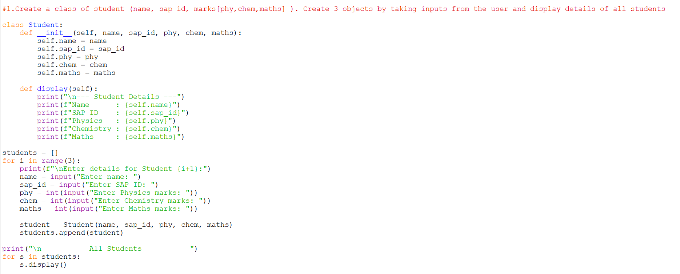
RESULT: -
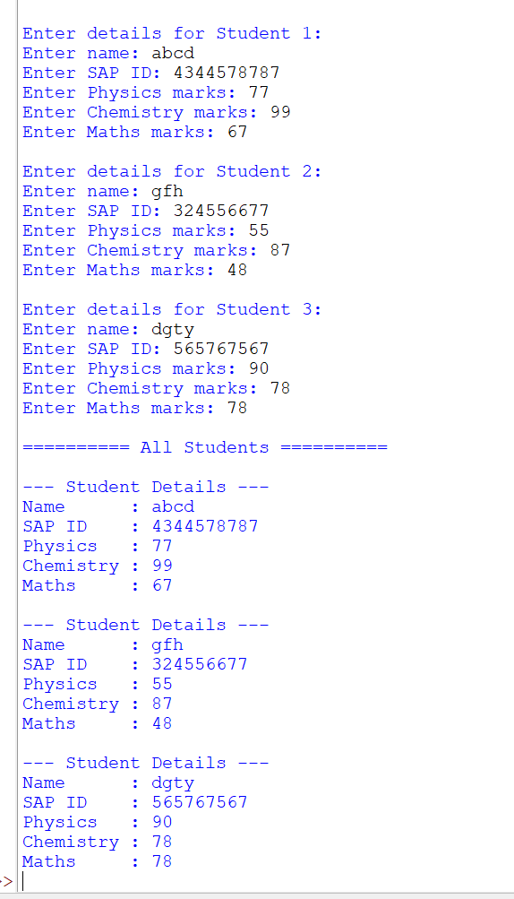
2. Add constructor in the above class to initialize student details of n students and implement following methods:
- a)Display() student details
- b)Find Marks_percentage() of each student
- c)Display result() [Note: if marks in each subject >40% than Pass else Fail]
- d)Write a Function to find average of the class.
CODE: -
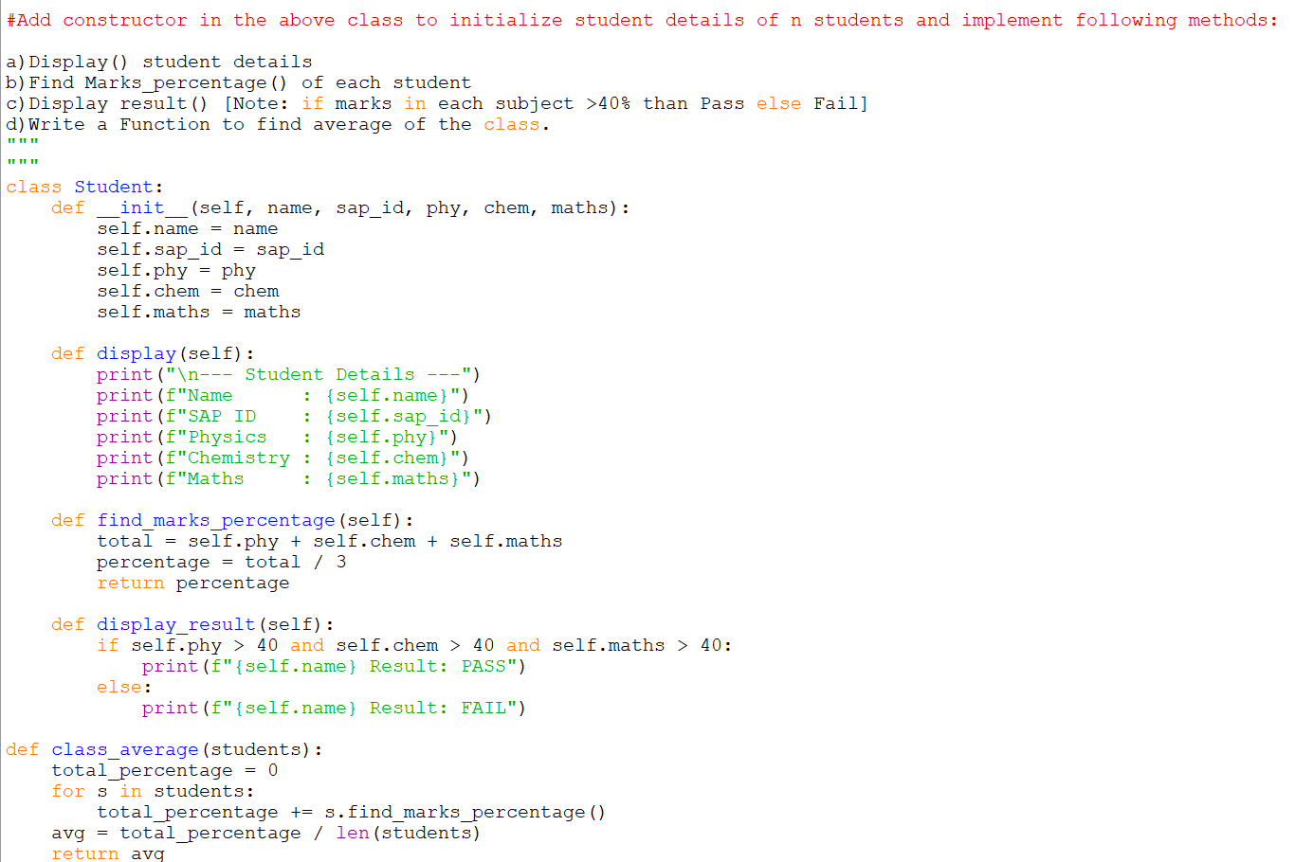
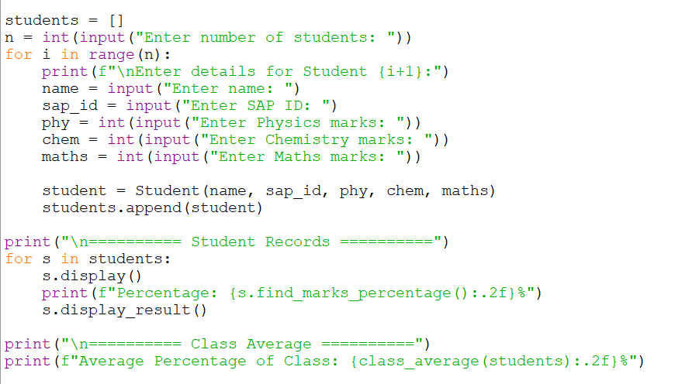
RESULT: -
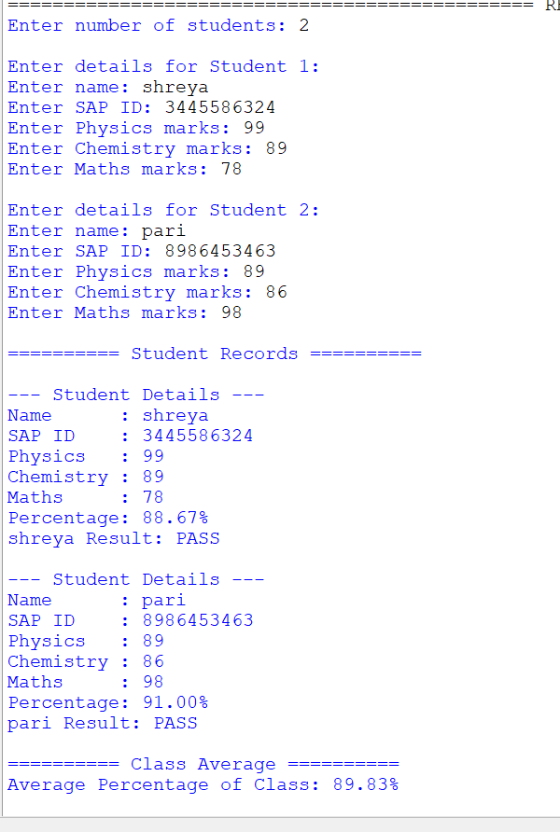
3. Create programs to implement different types of inheritances
CODE: -
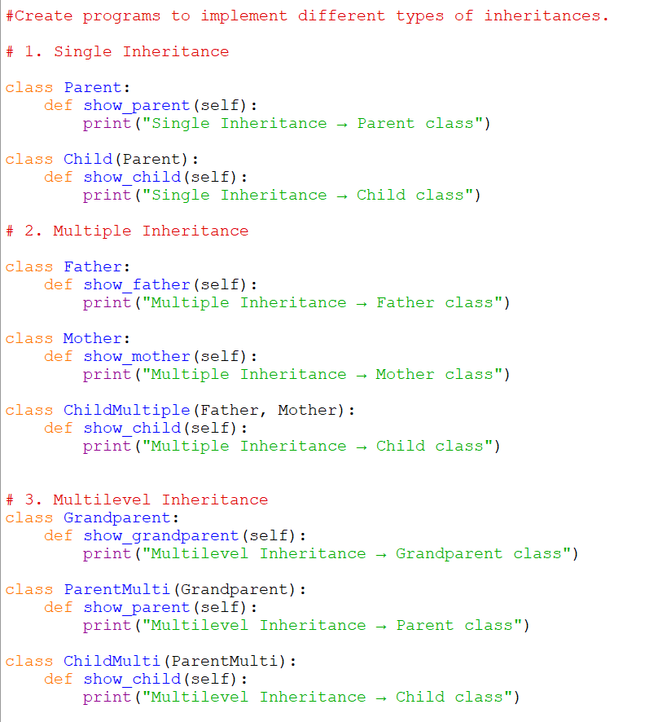
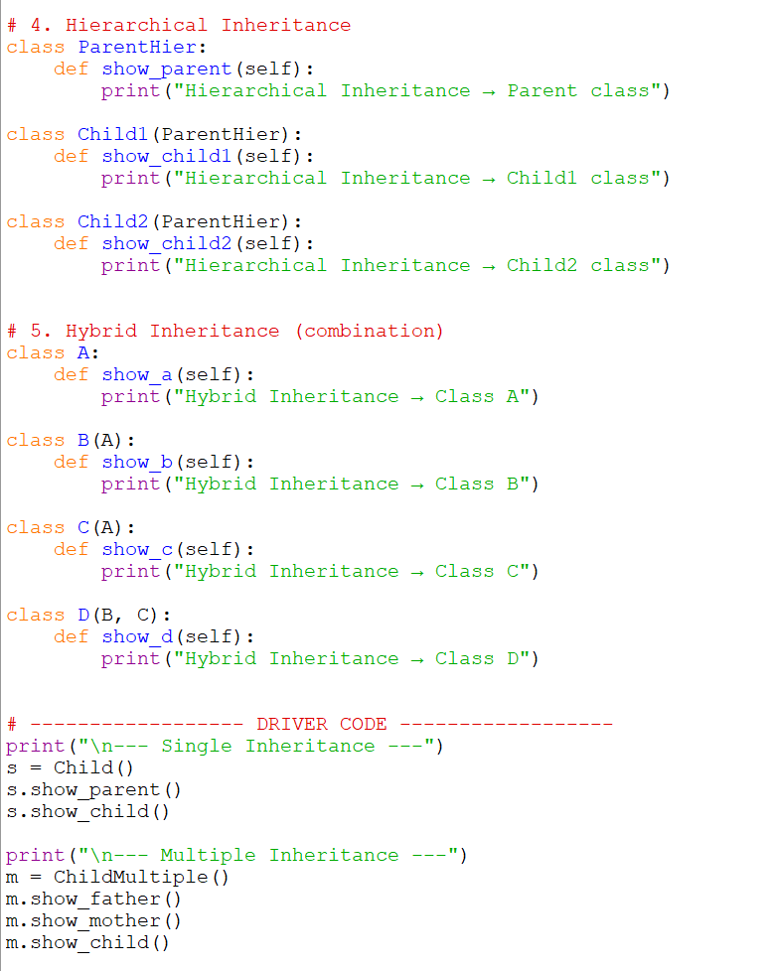
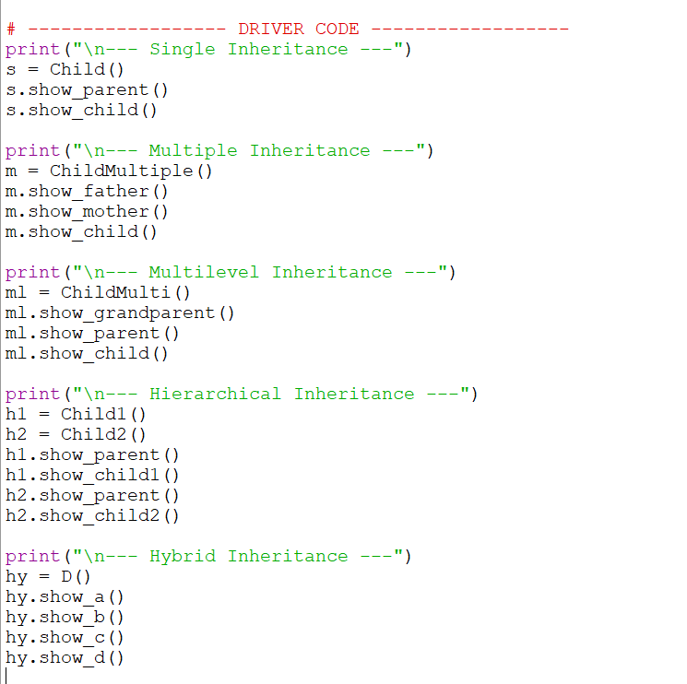

RESULT: -
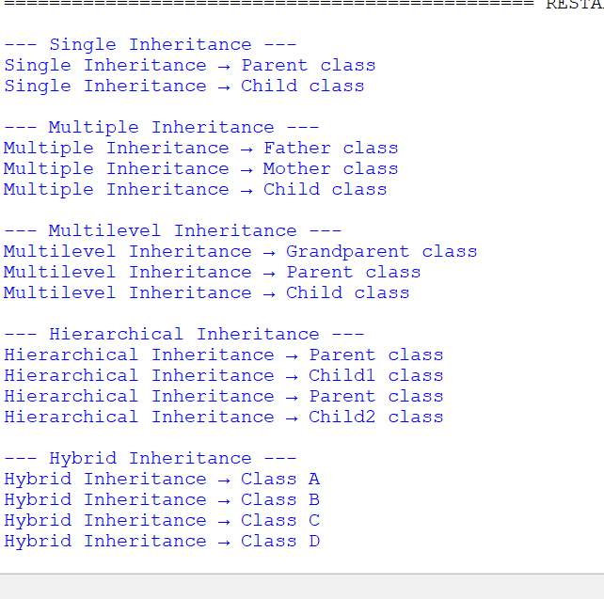
4. Create a class to implement method Overriding.
CODE: -
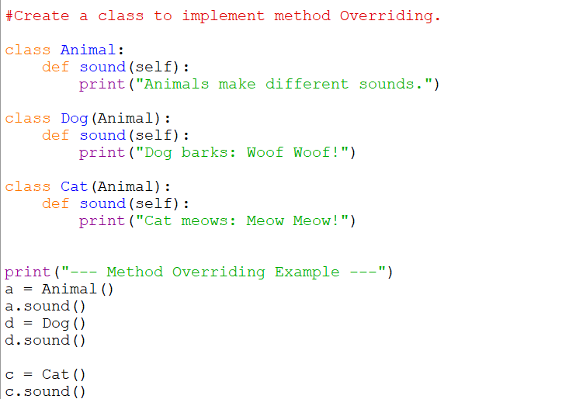
RESULT: -
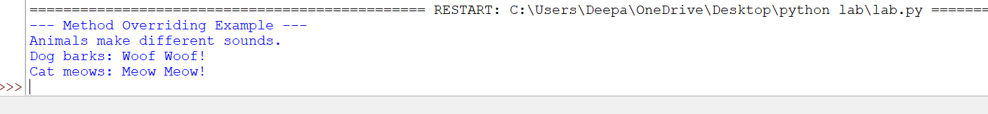

5. Create a class for operator overloading which adds two Point Objects where Point has x & y values
e.g. if
P1(x=10,y=20)
P2(x=12,y=15)
P3=P1+P2 => P3(x=22,y=35)
CODE: -
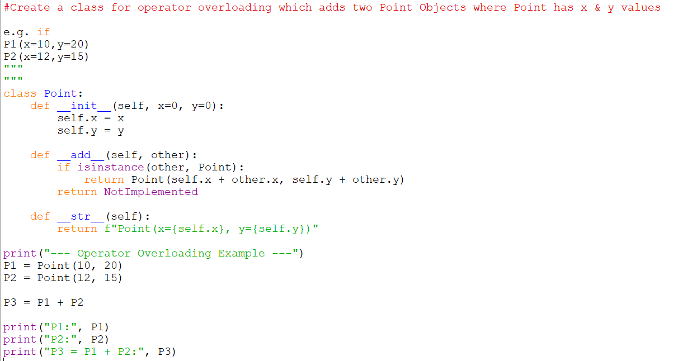
RESULT: -
